J2-P

EEC approved (L7e)

Positioning:
The delivery solution for the last mile of the city. Cold chain, takeaway, express delivery, logistics and supermarket distribution, etc., it is the short-distance cargo transportation vehicle within the city.

定位：
城市最后一公里的配送解决方案。冷链，外卖，快递，同城物流及超市配送等，极具性价比的城市内部短途货物运输车辆。
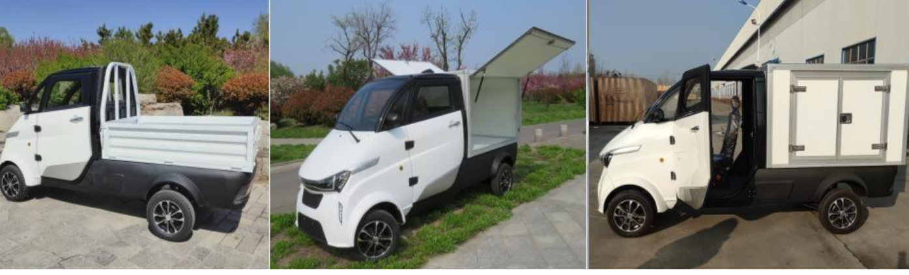
4 wheels, 1 seat 四轮，一座
Size: 3600*1345*1765mm 尺寸: 3600*1345*1765mm
The size of cargo box:1635*1150*1058mm 物流箱尺寸：1635*1150*1058mm
The size of hopper:1635*1150*370mm 货斗尺寸：1635*1150*370mm
Curb weight:510kg 整备重量：510kg
Loading capacity : 550kg 最大载重：550kg
Max. speed: :52km/h 速度：52km/h

105Ah lithium battery Max distance 90km ,with fast charge system, full charge in 3 hours;
105Ah 锂电池 最大续航里程 90km, 配备快充,，充满电时间3小时。
Options 206Ah lithium battery Max distance can reach 170km, with fast charge system, full charge in 6 hours.
可选配206Ah 锂电池 最大续航里程170km, 配备快充， 充满电时间6小时。

Options 412Ah lithium battery Max distance can reach 350km, with fast charge system, full charge in 6 hours.

Color: White&Silver Red&Silver Blue&Silver Grey&Black
颜色：白银，红银，蓝银，灰色，黑色

Details of the vehicle：
车身细节：

1. ABS Resin Plastic Cover and painting
Whole cover with ABS Resin plastic , have excellent comprehensive physical, impact resistance ,Stability, two-thirds lighter weight than iron.
ABS 树脂注塑, 具有优良的综合物理和机械性能，较好的低温抗冲击性能，尺寸稳定性。比铁质件轻三分之二。

Automobile-grade,Robot-painting .
汽车级油漆，电脑调漆，专业喷涂设备。
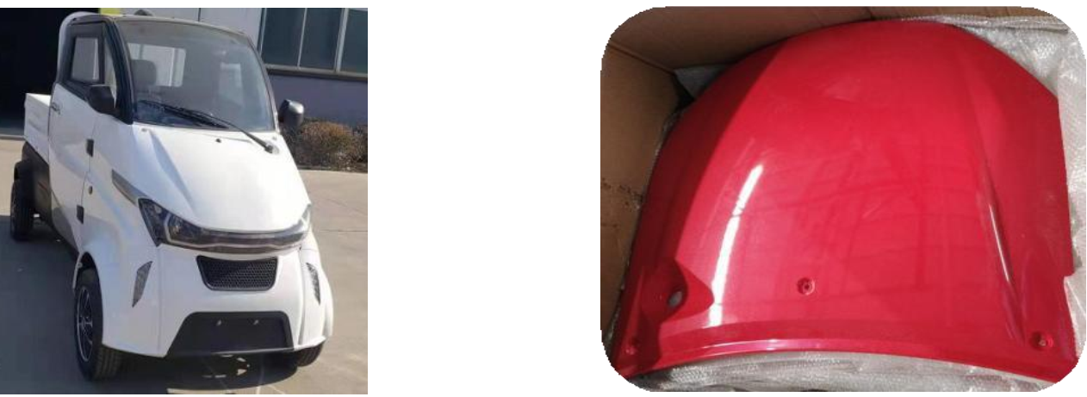
2, LED Light System
The integrate LED head &rear-light
Turn lights, brake lights, reverse lights. Low power consumption and increase 50% more in light transmittance.
前后远近光一体贯穿式LED大灯、转向灯、刹车灯、倒车灯。耗电量低，透光度提升 50%。
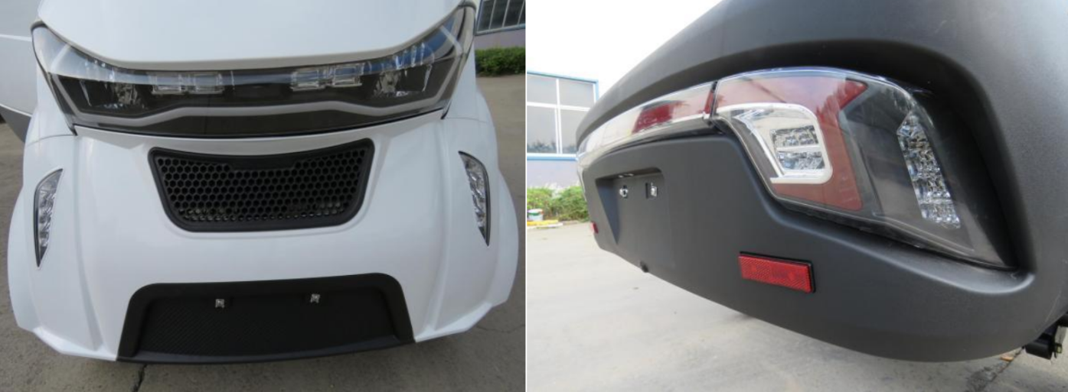
3, Front Windshield
CCC certified tempered and laminated glass Improve visual and more safety.
CCC 认证钢化夹层玻璃·提高视觉效果和安全性能。
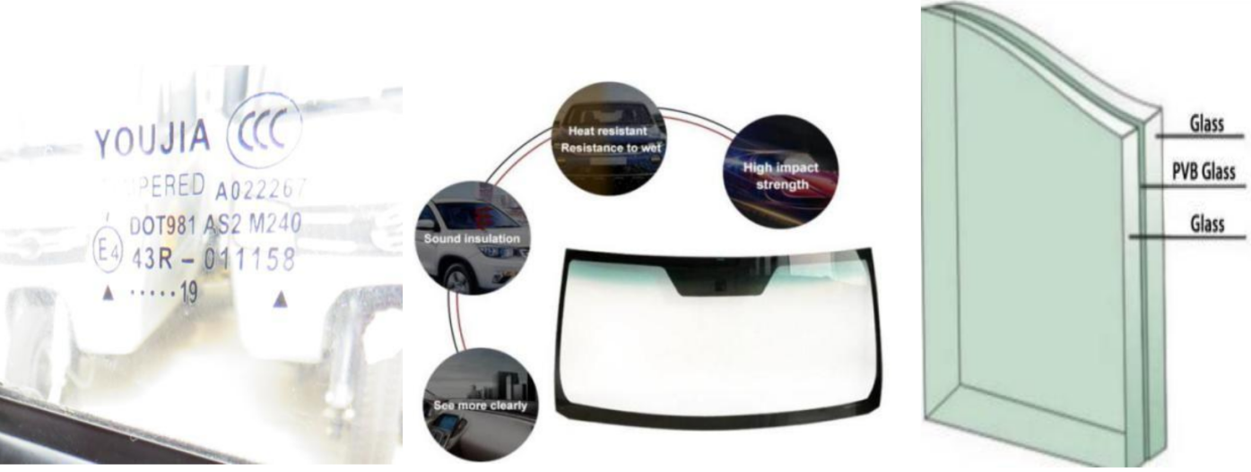
4,Dashboard
LCD display, volt meter, power meter, kilometer and reverse camera,plus Bluetooth, MP5,USB connector.
仪表台：整体液晶显示，电压表，电量表、里程表及倒车影像,蓝牙,MP5,USB 接口。
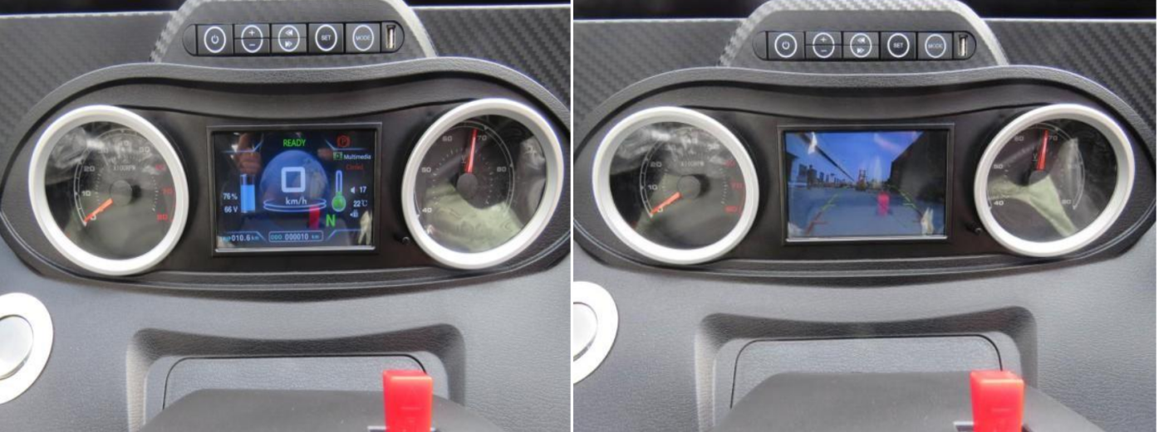
5,Central lock and One button start
中控钥匙，一键启动。
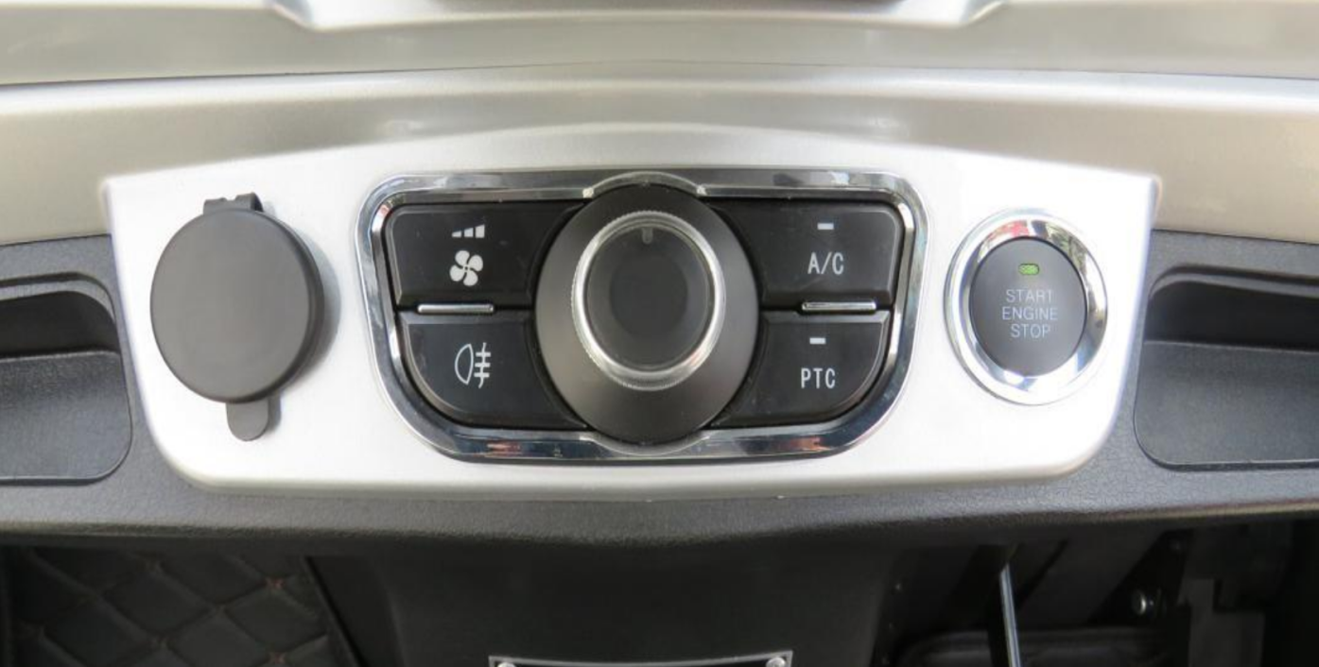
6,Electric Windows
电动窗户
7, Mat on the whole car 地垫

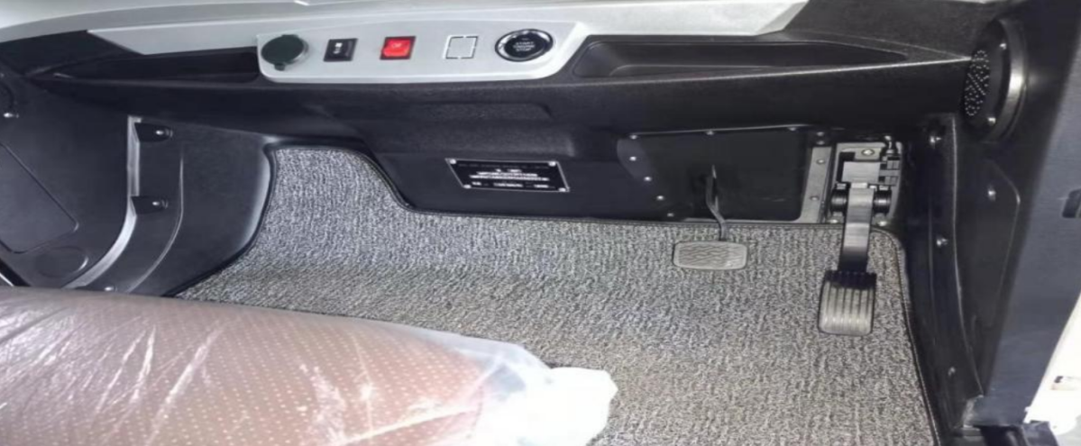
8, Optional Air Conditioner
可选配空调
9, Seat with belt
Genuine Leather with PU,optional rotating seat for easy getting on and off.
座椅:真皮面料+高回弹 PU。选配可旋转座椅，方便上下车。
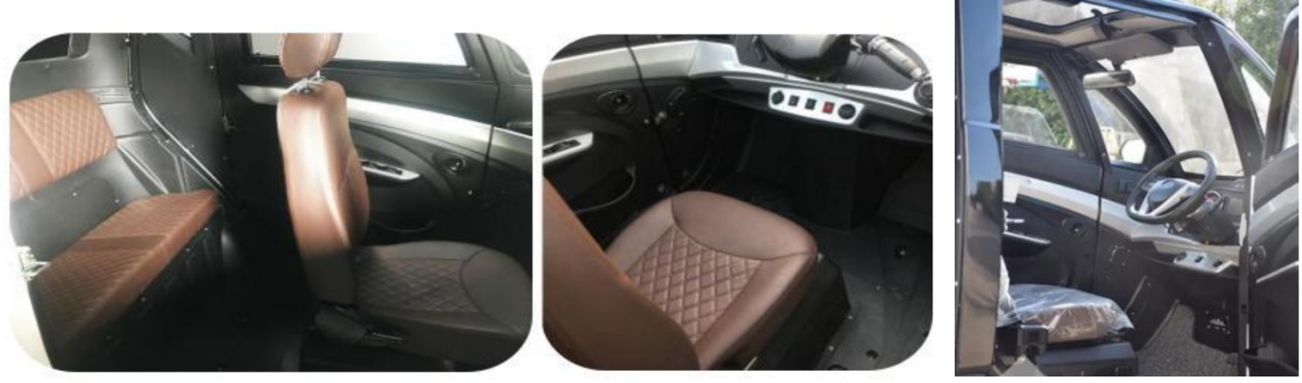

10.AC Motor (4000W)
AC motor with powerful and water proof, lower noise, no carbon brush, maintenance-free. Equipped with fast home charging system.
电机：交流动力电机，动力强大，低噪声，免维护，从而有效提升续航里程。配有上坡辅助系统。
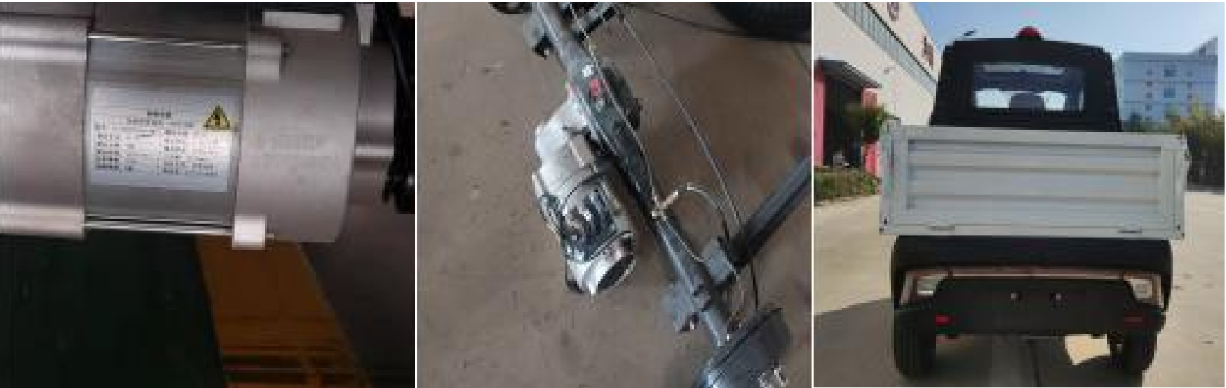
11.Lithium Iron Phosphate Battery
with BMS system, more than 2,500 times charging cycles(8-10 years) under working environment from -30 to 50 °C. Equipped with hill-start assist control.
电池:磷酸铁锂电池，安全性好，有 BMS 管理系统，可以在-30-50℃的工作环境， 循环充放电 2500 次，寿命 8-10 年左右。且配有上坡辅助系统。

Can be remote online monitoring. Automatic power off after full charge.
可监测：
实现远程在线监测，可通讯，充满自动停止。
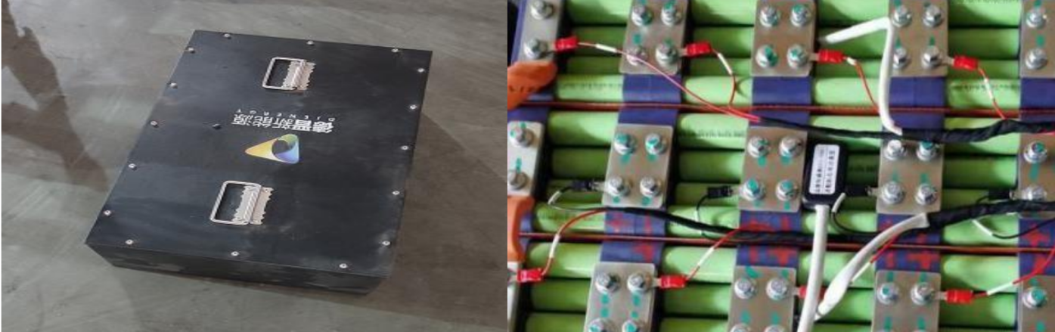
12.Electronic Control System
Use Enpower electric control system , reliable and water-proof
电控系统:采用英博尔电控系统，可靠性高及防水。
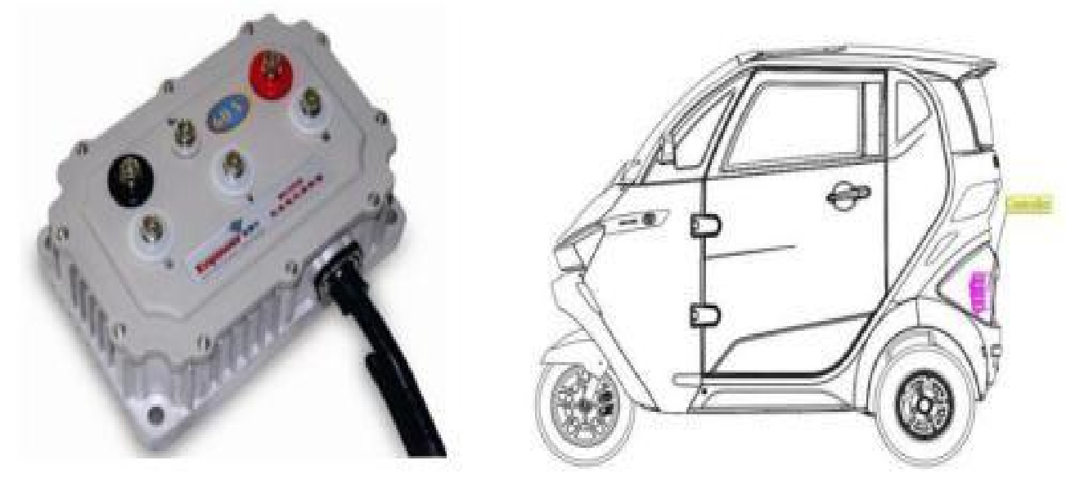

13. Brake System
Front-disc and Rear-drum,two-circuit hydraulic brake
制动系统： 前碟后鼓式双回路液压制动。

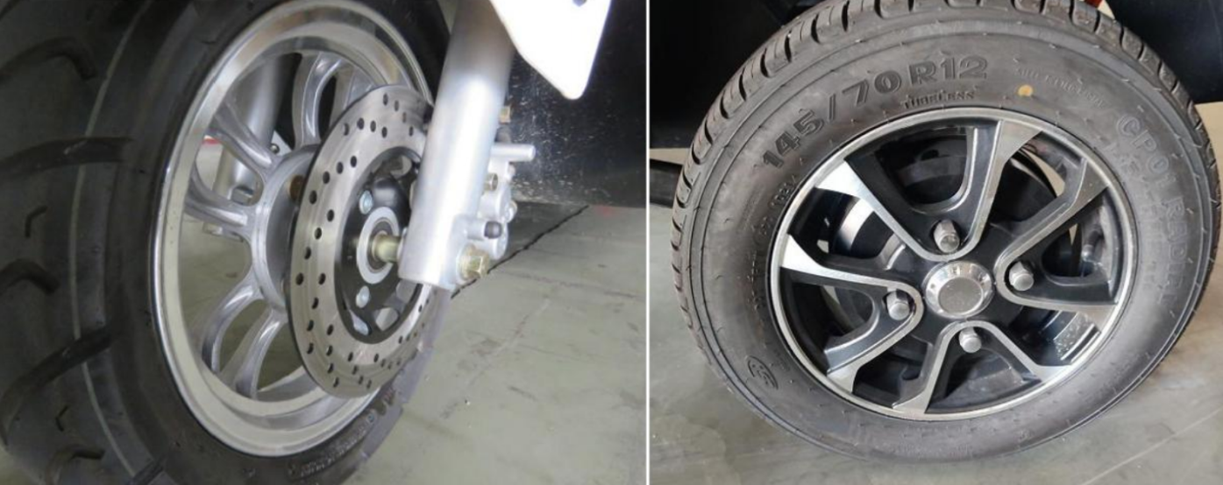
14.Suspension System
The front axle and suspension are independent suspensions, simple structure and excellent stability. The integrated rear axle,axle housing welded by seamless steel tube, lower noise,more durable and reliable.
悬挂系统:前桥及悬挂为独立悬挂，结构简单，稳定性好。后桥为整体式后桥、无缝钢管焊接桥壳，噪音低, 可靠。
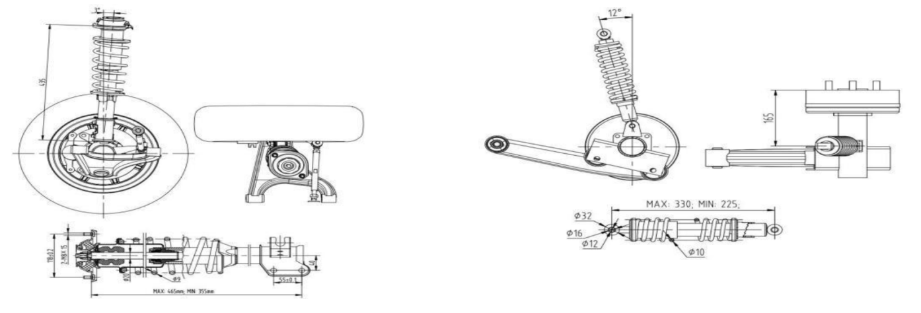
15.Frame&Chassis
GB Standard Steel, under pickling，Photostatting and corrosion-resistant treatment
车架及底盘：采用国标钢材，整体表面经酸洗磷化耐腐蚀处理

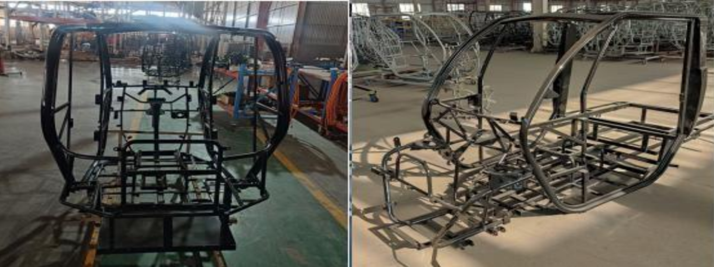
Several kinds of Cargo Box for choose:
多种货箱可供选择：

1, Logistics Box-- Cellular panel（side open or wing open）:
物流箱-蜂窝板（单侧开门，双侧开门）
Size:1635*1150*1058mm
尺寸:1635*1150*1058mm

With comprehensive strength,bending resistance, excellent properties such as corrosion resistance and high temperature resistance. 70-90% lighter than solid palate.
是由蜂窝板材料制作，其特殊的结构，抗压强度高，抗弯特性，比同厚度的实心板轻70-90%，具有耐腐蚀、耐高温等多种优异性能。
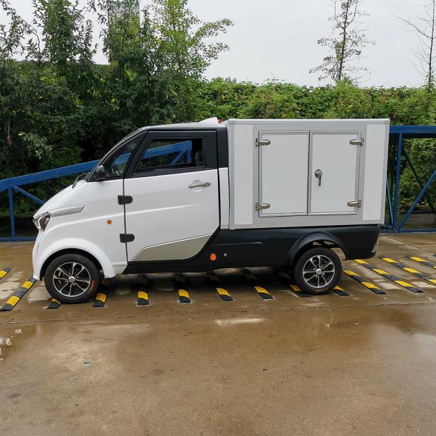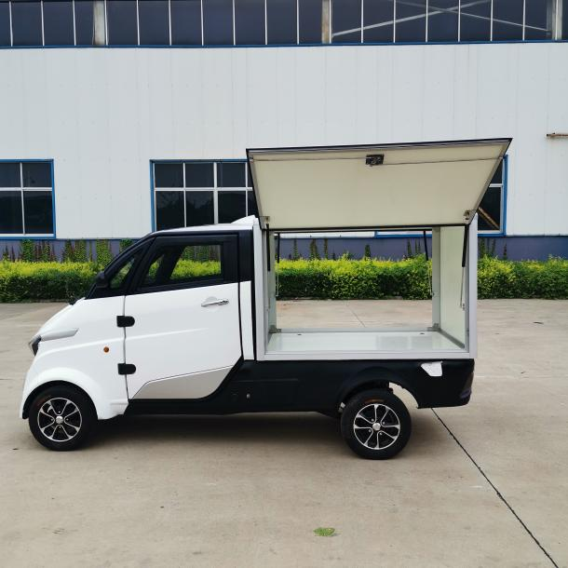
V01 one side door 单侧开门 V02 Double sides door 双侧开门

2,Optional Cargo Box-Equip with cooling system and heating system.
可选配货箱-配备制冷制热系统。

Size:11635*1150*1058mm
尺寸：1635*1150*1058mm

Cooling system design for fruit,vegetable, seafood, drinks, medicine transportation, from -18 ℃ to 10 ℃;
为水果，蔬菜，海鲜，饮料，药品运输设计了制冷系统，可调节制冷温度-18℃到10℃
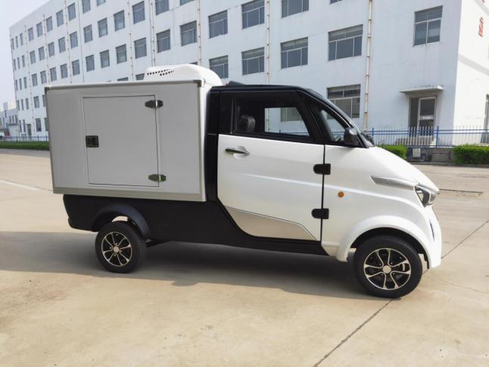
V03 制冷物流箱

Heating system design for takeaway , temperature from 40℃to 60 ℃. Cargo box can be divided to two space, one for cooling and one for heating.
为外卖派送设计了制热系统，可调节温度40℃到60℃。一个箱子也可以分割成制热制冷箱。顾客可根据需求调节温度， 来很好的保护运输的食品或药品。
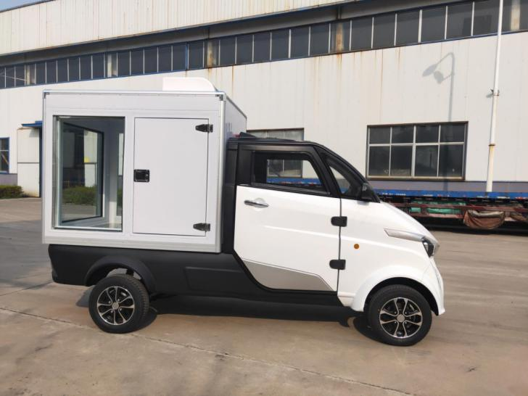
半制冷半制热物流箱

3, Aluminium alloy hopper
铝合金车斗：
Size:1635*1345*370mm
尺寸: 1635*1345*370mm
After heat treatment and alloying strengthening.
经过热处理强化及合金化强化，其强度会大幅增加
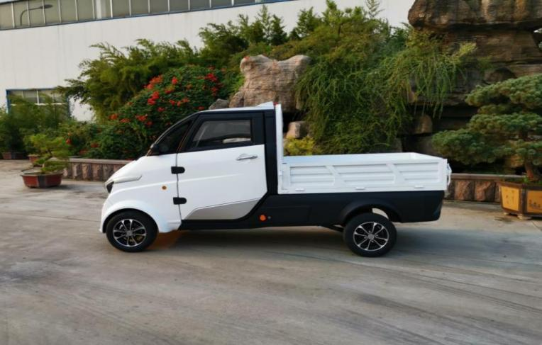
Advantage:
优势:
1. Save Cost
CKD (Completely Knocked Down) assembly reduce and save customs duty & transportation cost
节约成本：非常简单的可以实现当地 CKD 组装，降低关税，降低运输成本。
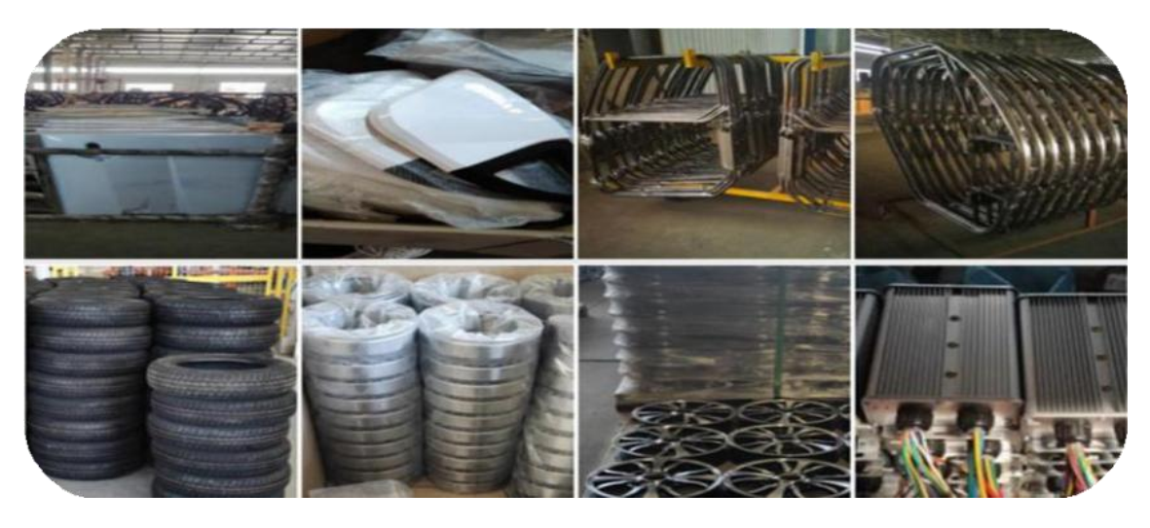

2. Save time
Fast charger within 5~6 hours under home charger
节约时间：可以用家用电源实现5~6小时快充
3.Car sharing system
Customers can download the APP, scan the QR code on the vehicle, Users can pay the cost directly online .The company can manage all vehicles through the phones.
客户下载APP，扫描车辆上的二维码码后可以使用，并通过线上或者信用卡可以直接使用的费用支付。公司通过后台可以管理所有的车辆。

